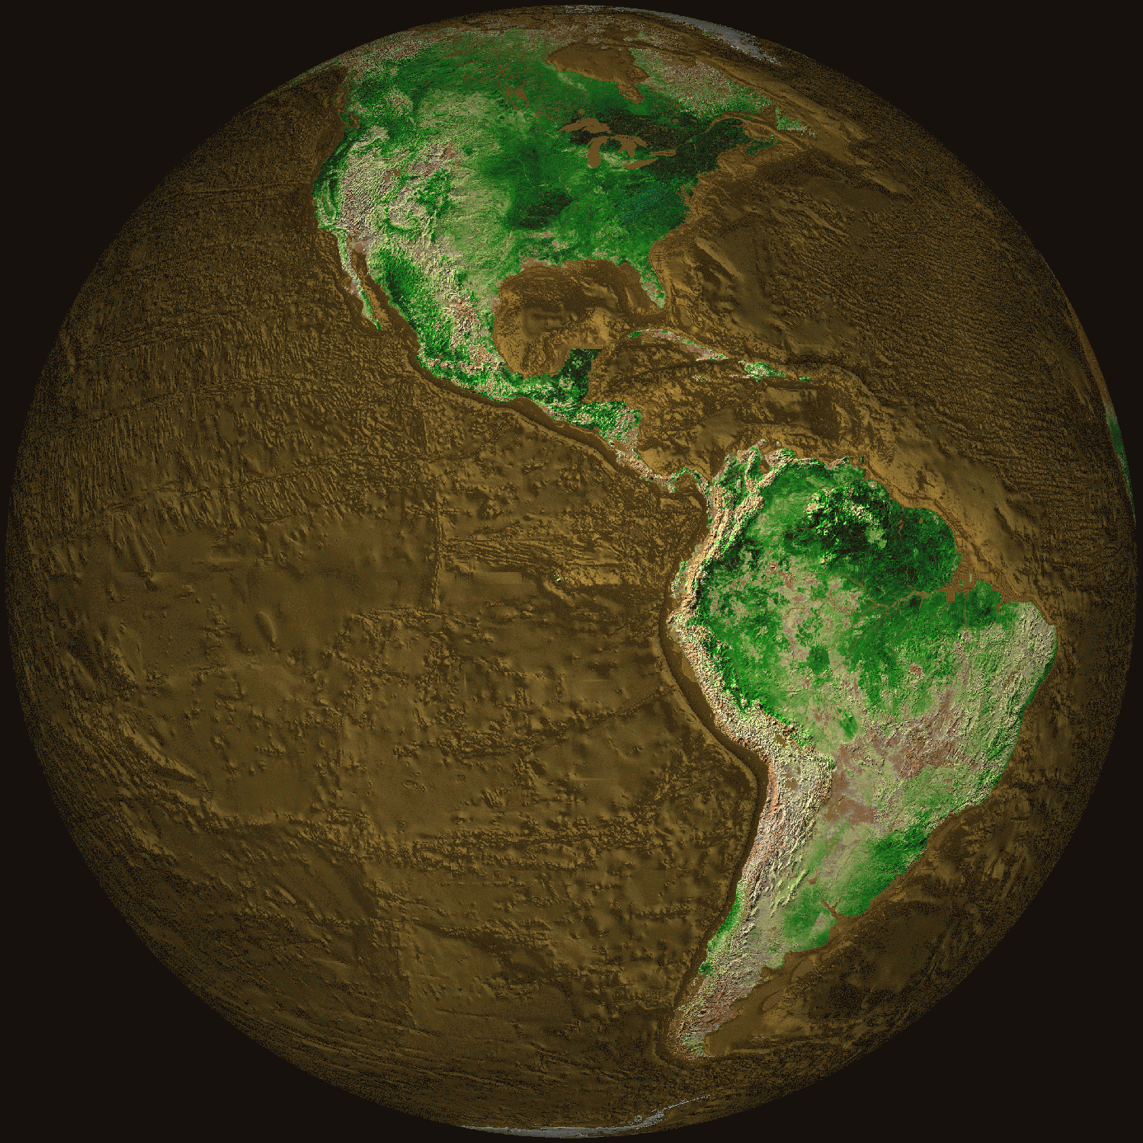
Figure 1 – High and Low
Terrain of the Earth
Did you know?
1 The surface of Earth is not flat. Some places are high and some places are low. For example, mountain ranges like the Sierra Nevada in California or the Andes in South America are high above the surrounding areas.
2 We can describe the topography of a mountain or a valley by measuring the height or depth above sea level.
3 Terrain (French for piece of earth, ground, land), includes all the landforms of a region. A Terrain map shows the height, or elevation, of features in an area. This includes mountains, craters, valleys, and rivers (See Figure 1).
So, why is it important to me?

4 Earth’s surface features are a result of forces of water and gravity acting on the rocks and soils. Underwater features are a result of ocean water flow and volcanic activity.
5 Land filters our drinking water and we build homes on land that was formed by water.
What are the big ideas I need to know?

6 Rivers and streams flow across continents. They cut away at rock, forming river valleys. Moving water is a destructive force. Mountains are worn down by the action of water, wind, freezing and thawing (See Figure 2).
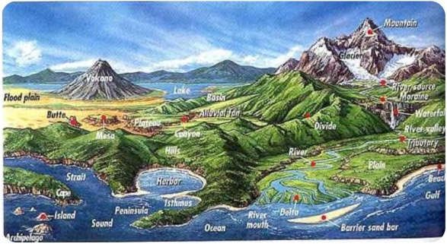
Figure 2 – Several landform features of the surface.
7 Moving water is also a constructive force that makes new land. The bits and pieces of rock and plants that are carried by rivers are deposited where the rivers meet the oceans. These can form deltas with rich soil. They can also form barrier islands that protect shorelines. Rivers bring sand to the shore, which forms our beaches.
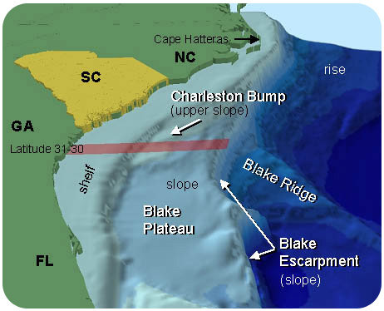
Figure 3 – The continental shelf.

8 The ocean basin begins where the ocean meets the land. The continental margin begins at the shore and goes down to the ocean floor. It includes the continental shelf, slope, and rise. The continental shelf usually goes out about 100 to 200 kilometers from the shore (See Figure 3).
9 Mapping is an important part of Earth Science. Topographic maps use a line, called a contour line, to show different elevations on a map. Contour lines show the location of hills, mountains and valleys.

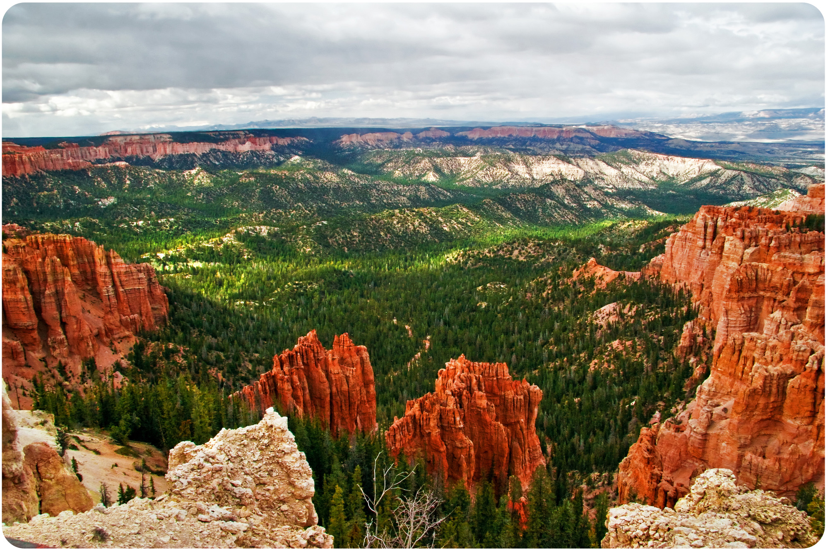
Figure 4 – A Picture of Swamp Canyon
in Bryce Canyon National Park

10 Contour lines connect all the points on the map that have the same elevation. Each contour line represents a specific elevation. By knowing the height of a hill or mountain, we can make a map that shows a mountain, as if you sliced it into sections (See Figure 4).
11 Since each contour line represents a specific elevation, two different contours are separated by the same difference in elevation, a contour interval (e.g. 20 ft. or 100 ft.). The legend on the map also gives the contour interval.

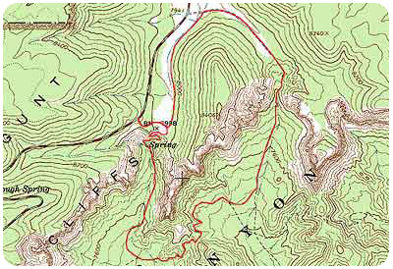
Figure 5 – A Topographic map of Swamp Canyon in Bryce Canyon National Park
12 The spacing of contour lines shows the slope of the land. Contour lines that are close together indicate a steep slope. This is because the elevation changes quickly in a small area. Contour lines that seem to touch indicate a very steep slope, like a cliff. When contour lines are spaced far apart the slope is gentle (See Figure 5).
13 Concentric circles indicate a hill (See Figure 6). When contour lines form closed loops, there is a hill. The smallest loops are the higher elevations on the hill. The larger loops encircling the smaller loops are downhill.

Figure 6 – Cady Hill on a Topographic Map

14 Hatched concentric circles indicate a depression. The hatch marks are short, perpendicular lines inside the circle. The innermost hatched circle represents the deepest part of the depression (See Figure 7).

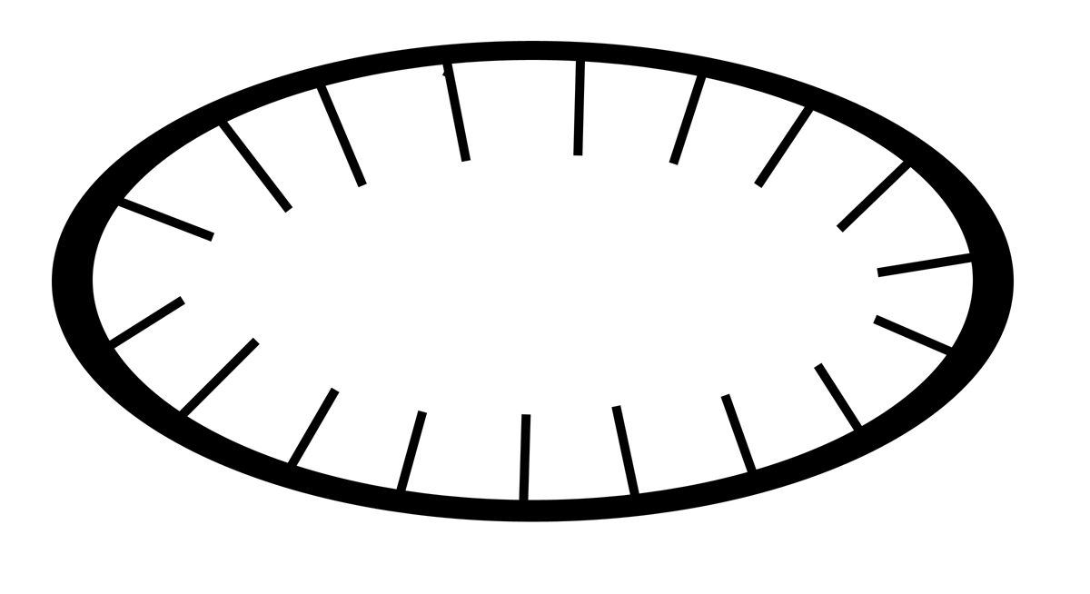Figure 7 – A depression on a Topographic Map

What about?

15 The V-shaped portions of contour lines indicate stream valleys. The “V“shape of the contour lines point uphill. There is a V shape because the stream channel passes through the point of the V. The open end of the V represents the downstream portion. A blue line indicates that there is water running through the valley.

