
Did you know?


Figure 1 – We use energy all the time.

1 Energy provides the ability to move or change matter. Every living thing needs energy to live and grow. Your body gets its energy from food, but that is only a small part of the energy you use every day. Cooking your food takes energy, and so does keeping it cold in the refrigerator or the freezer (See Fig. 1).
2 Energy resources can be put into two categories — renewable or nonrenewable. Nonrenewable resources are used faster than they can be replaced.
3 Fossil fuels include coal, oil, and natural gas and are examples of nonrenewable resources. Fossil fuels are the greatest energy source for modern society (See Fig. 2).

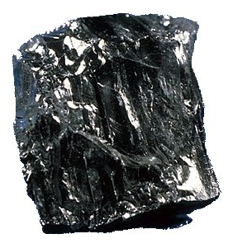
Figure 2 – Coal is formed from decaying
plant material over millions of years.

4 Fossil fuels are made from plants and animals that lived hundreds of millions of years ago. The plants and animals died. Their remains settled onto the ground and at the bottom of the sea. They experienced intense heat and pressure. Over millions of years, the organic material turned into fossil fuels.
So, why is it important to me?

5 Most of our energy comes from nonrenewable resources. We need to understand how to make them last longer and use them wisely. Once they are gone, they are gone.
6 Energy is becoming more and more expensive. We need to understand the costs of using nonrenewable resources.
What are the big ideas I need to know?
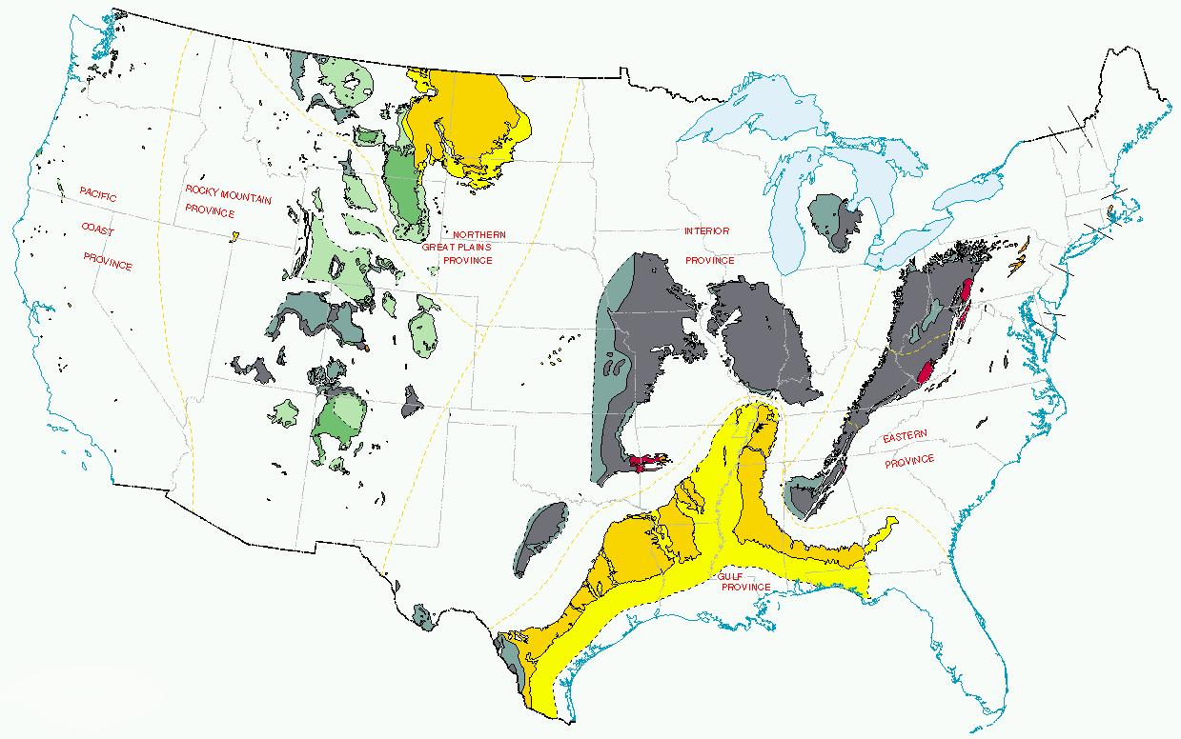Figure 3 – United States coal-producing regions.

7 Fossil fuels are compounds of carbon and hydrogen, called hydrocarbons. Hydrocarbons can be solid, liquid, or gas. The solid form is coal. The liquid form is petroleum, or crude oil. The gaseous form is natural gas (See Fig. 3).
8 Coal forms from dead plants that settled at the bottom of swamps millions of years ago. Water and mud in the swamp kept oxygen away from the plant material. Sand and clay settled on top of the decaying plants. The weight of this material squeezed out the water and some other substances. Over time, the organic material became a carbon-rich rock we call coal.

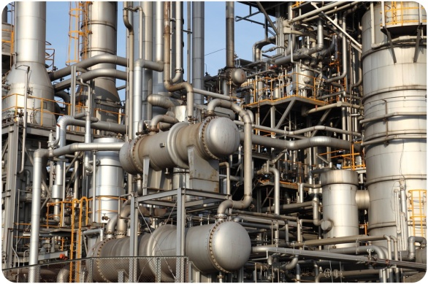
Figure 4 –This oil refinery processes crude oil into usable energy sources, such as gasoline.

9 Oil is a thick, dark brown or black liquid. The way oil forms is similar in many ways to coal. Tiny organisms like plankton and algae die and settle to the bottom of the sea. Sediments settle over the organic material. Oxygen is kept away by the sediments. When the material is buried deep enough, it is exposed to high heat and pressure. Over millions of years, the organic material transforms into liquid oil (See Fig. 4).

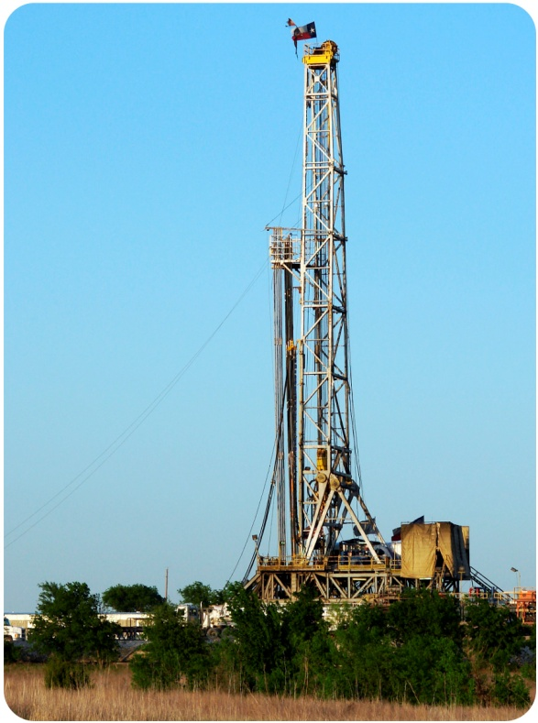
Figure 5 –This oil refinery processes crude oil into usable energy sources, such as gasoline.

10 Natural gas is often found along with coal or oil in underground deposits. This is because natural gas forms with these other fossil fuels. One difference between natural gas and oil is that natural gas forms at higher temperatures (See Fig. 5).
11 Unfortunately, drilling for natural gas can be environmentally destructive. One technique used is hydraulic fracturing, also called fracking, which increases the rate of recovery of natural gas.
What about?

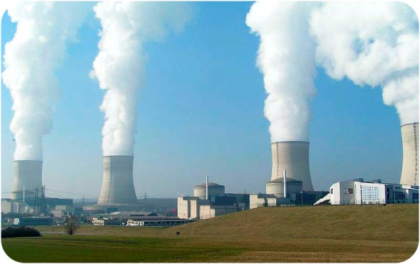Figure 6 – A nuclear power plant – the smoke
seen is steam from cooling towers.

12 Nuclear power is clean. It does not pollute the air. However, the use of nuclear energy does create other environmental problems. Uranium must be mined (See Fig. 6).
13 The process of splitting atoms creates radioactive waste, which remains dangerous for thousands or hundreds of thousands of years. As yet, there is no long-term solution for storing this waste.

