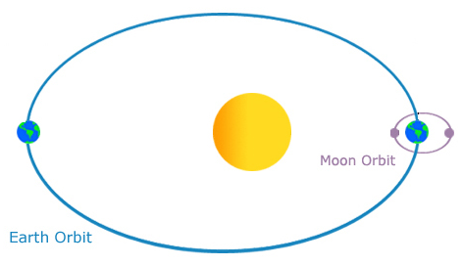
Figure 1 – Earth, the moon and the sun
Did you know?
1 In our solar system, Earth revolves around the sun (orbits) once a year, or once about every 365.2425 days. Every four years we correct calendars with a "Leap Year".
2 Earth rotates (spins on its axis) every 24 hours or once a day. The moon revolves around Earth about once every 29.5 days (See Fig. 1). The moon also rotates once in that same time so the same side always faces the Earth.
So, why is it important to me?

3 Separating facts about the position of the moon, Earth and sun from myths, clears up a lot of misunderstandings through history.
4 Because of the positions of the moon, Earth and sun, there are tides and eclipses. We can see the moon partially illuminated in distinct, understandable and repeated phases.
What are the big ideas I need to know?

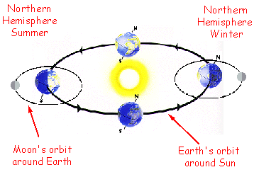
Figure 2 – Seasons on Earth due to the
angle of the light that comes from the sun.

5 Because Earth's axis is tilted 23.5°, we have seasons (See Fig. 2). The hemisphere that is tilted away from the sun is always cooler because it receives less direct rays. As Earth orbits the sun, the Northern hemisphere goes from winter to spring, then summer and fall.
6 In the Northern hemisphere, daytime is shortest when the North Pole is facing furthest away from the sun (the winter solstice) and it is longest six months later when it is facing the sun most directly (the summer solstice).
7 Halfway between Summer and Winter, there is a time when the sun is directly over the equator at noon known as the fall equinox. This happens again six months later when the sun is directly over the equator at noon during the spring equinox.
8 Summer, Fall, Winter and Spring are all reversed for the Southern hemisphere. There, Summer is in December, Fall is in March, Winter is in June and Spring is in September.
9 It takes about 29.5 days for the moon to make one cycle relative to the sun and go through all the phases (See Fig. 3). The time between two new moon phases or two full moon phases is 29½ days.
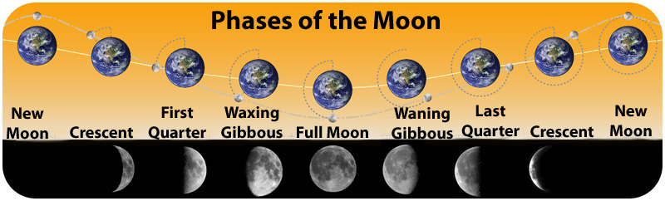
Figure 3 – Phases of the moon as if the sun is above the
top of this picture with its rays directed downward.
10 Tides are the regular rising and falling of Earth’s surface water because of the gravitational attraction of the moon and sun. The moon’s gravity pulls upwards on Earth’s water, causing it to bulge out in the direction of the moon. When the Earth and sun are in line but the moon is not, a smaller tide or neap tide happens.

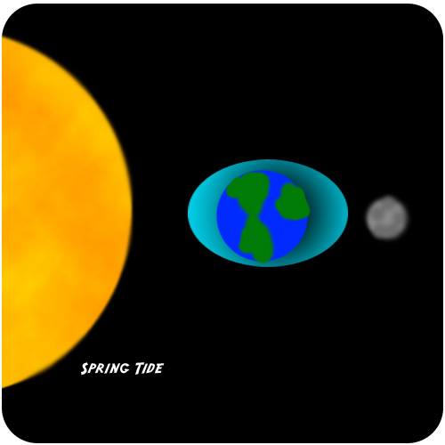 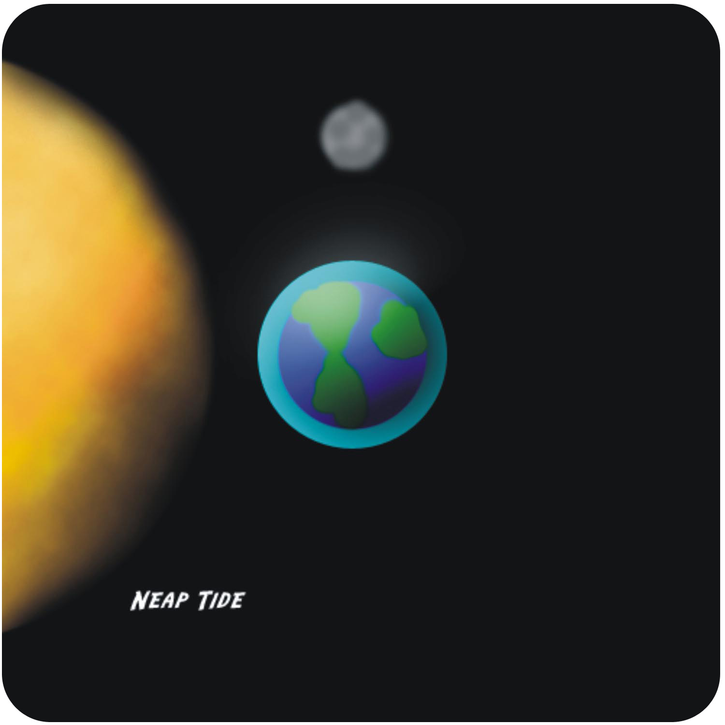
Figure 4 –Very high and very low tides due to position of the moon.

11 As the Earth rotates on its axis, the areas directly in line with the moon experience high tides. There are two high tides and two low tides each day (See Fig. 4).

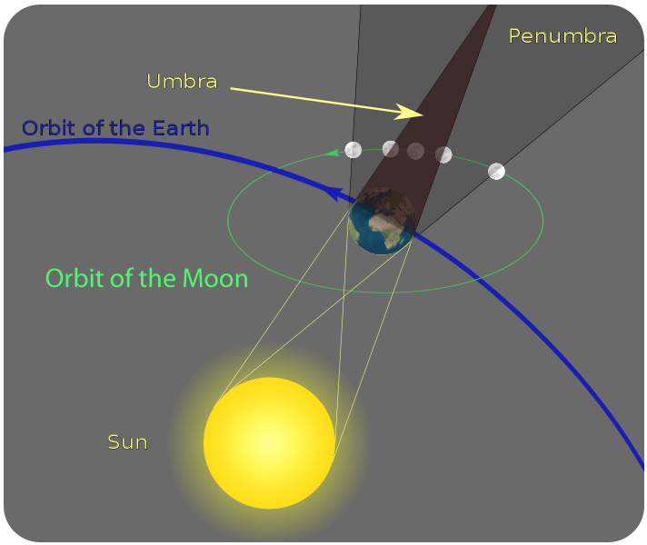 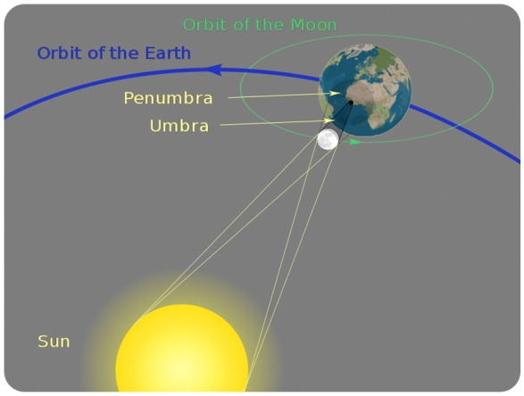
Figure 5 –Lunar (L) and Solar (R) eclipse.

12 When a new moon passes directly between the Earth and the sun, it causes a solar eclipse. The moon casts a shadow on the Earth and blocks our view of the sun. This happens only when all three are lined up in this order.
13 The moon’s shadow has two distinct parts. The umbra is the inner, cone-shaped part of the shadow where all of the light has been blocked. The penumbra is the outer part of moon’s shadow where the light is only partially blocked.
14 When Earth’s shadow falls on the moon, it is a lunar eclipse. Because of the angle of the moon’s orbit, lunar eclipses are not common. Solar eclipses are also rare events. Both solar and lunar eclipses usually only last a few minutes. (See Fig. 5).
What about?
15 During a total Solar eclipse, the moon hides the sun for only a short amount of time as Earth and the moon are moving through space at a fast speed.

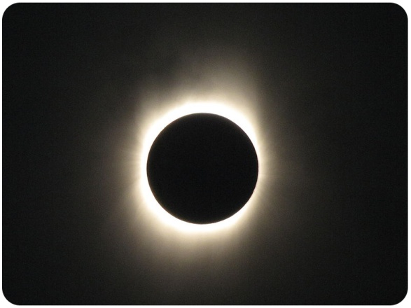Figure 6 –A full Solar eclipse.

16 You can watch a Solar eclipse with special equipment. Never look directly at the sun without taking safety precautions or you may permanently damage your eyes (See Fig. 6).

