Grade Rubric & Help : 1__ 2 __ 3 __ 4 __ 5 __ 6 __ 7 __ 8 __ 9 __ 10 __ Total: ____ Grade: ___ Graded by: _______________
©2013 StarMaterials.com Unauthorized reproduction is prohibited. Revised 2/20/2013
.Name: ________________________
1 ____ Earth Science 2 ____ Late __ Date: __ / __ / ___ Period ___ Room ___
Directions:
1- Fill in words based on the words around them and their meanings.
2- Each word in the word bank will be used once.
3- Complete the organizer below.
Read About
RAE 033

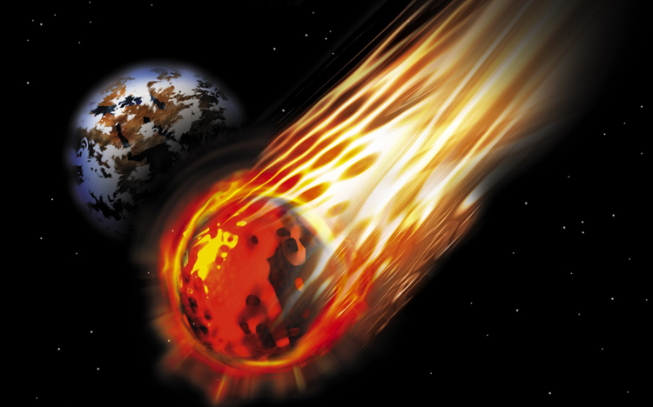
Word Bank

an friction glowed it
large make school
space usually world

Hit all the time

Fact #2
Fact #1
Organize Your Thoughts

Meteor Hits Earth!

A meteor entered the atmosphere over Russia and caused a lot of damage. A piece of (1)________ rock a little over the size of a (2)________ bus hit the atmosphere at around 40,000 miles (3)________ hour. At that speed, it blew apart when (4)________ came in contact with dense air layers and (5)________ brightly due to the intense heating caused by (6)________.
Earth is constantly being bombarded by meteors, but (7)________ they become small by the time they (8)________ it through our atmosphere. The Russian meteor was relatively (9)________. It entered over a populated area of the (10)________. The meteor was also caught on video by many cameras.

