Grade [Rubric](http://www.starmaterials.com/Help/Cloze_Rubric.htm) & [Help](http://www.starmaterials.com/Help/Cloze) : 1__ 2 __ 3 __ 4 __ 5 __ 6 __ 7 __ 8 __ 9 __ 10 __ Total: ____ Grade: ___ Graded by: _______________  
©2013 [StarMaterials.com](http://www.starmaterials.com) Unauthorized reproduction is prohibited. Revised 2/20/2013

|  |
| --- |
| .Name: **________________________**  1 ____ Earth Science 2 ____ Late __ Date: __ / __ / ___ Period ___ Room ___ |

**Directions**:  
1- Fill in words based on the words around them and their meanings.

2- Each word in the word bank will be used once.  
3- Complete the organizer below.

Read About   
RAE 036

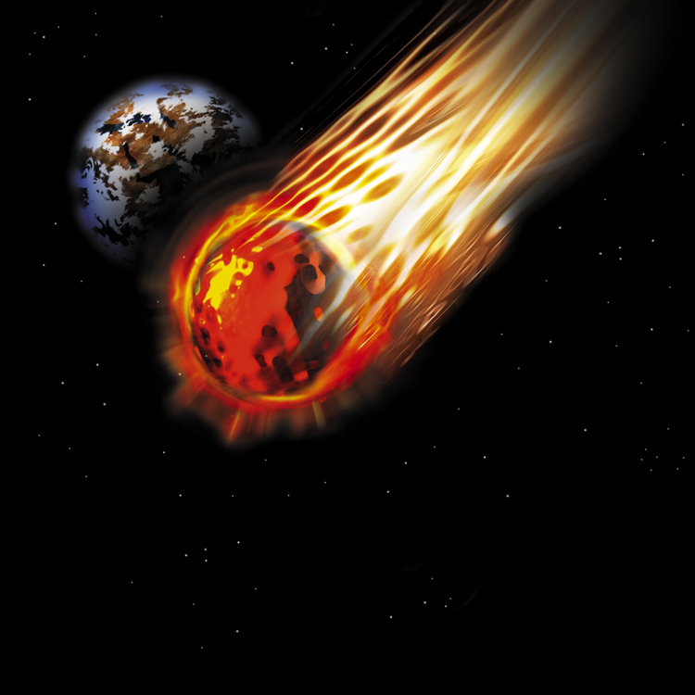

Hit all the time

Fact #2

Fact #1

**Organize Your Thoughts**

**Meteor Hits Earth!**

A meteor entered the atmosphere over Russia and caused a lot of damage. A piece of (1)________ rock a little over the size of a (2)________ bus hit the atmosphere at around 40,000 (3)________ an hour. At that speed, it blew apart when it came in contact with dense air layers and glowed brightly due to the intense heating caused by (4)________.

Earth is constantly being bombarded by meteors, but (5)________ they become small by the time they make it (6)________ our atmosphere. There were three major differences (7)________ time. The Russian meteor was relatively large, it (8)________ over a populated area of the world, and it was (9)________ on video by so many cameras. With Earth being three quarters water, and much of the remaining land being unpopulated, it is rare that we can see these events at all.

**Word Bank**

caught entered friction   
miles school space this through usually