Grade Rubric & Help : 1__ 2 __ 3 __ 4 __ 5 __ 6 __ 7 __ 8 __ 9 __ 10 __ Total: ____ Grade: ___ Graded by: _______________
©2013 StarMaterials.com Unauthorized reproduction is prohibited. Revised 5/2/2013
.Name: ________________________
1 ____ Earth Science 2 ____ Late __ Date: __ / __ / ___ Period ___ Room ___
Directions:
1- Fill in words based on the words around them and their meanings.
2- Each word in the word bank will be used once.
3- Complete the organizer below.
Read About
RAE 073
Material from NASA.gov

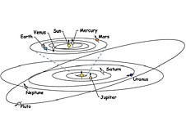
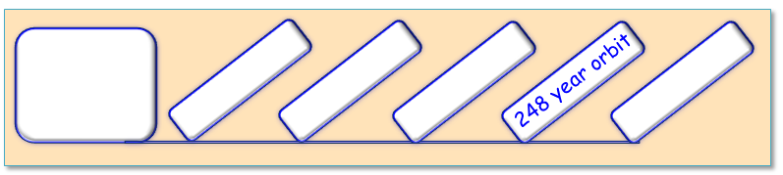
Word Bank

away billion closer
named ninth orbits
smallest times
Organize Your Thoughts
Why is Pluto Not a Planet Anymore?
Pluto was discovered in 1930 by an astronomer from the United States. Pluto was known as the (1)________ planet in the solar system and the (2)________ planet from the sun.

On average, Pluto is more than 3.6 (3)________ miles (5.8 billion kilometers) (4)________ from the sun. Pluto (5)________ the sun in an oval like a racetrack. Because of its oval orbit, Pluto is sometimes (6)________ to the sun than at other (7)________. At its closest point to the sun Pluto is still billions of miles away.

Pluto was (8)________ by an 11-year-old girl from England. Maybe you can name something too!

Ref: http://scijinks.jpl.nasa.gov/blue-sky

