Grade Rubric & Help : 1__ 2 __ 3 __ 4 __ 5 __ 6 __ 7 __ 8 __ 9 __ 10 __ Total: ____ Grade: ___ Graded by: _______________
©2013 StarMaterials.com Unauthorized reproduction is prohibited. Revised 5/2/2013
.Name: ________________________
1 ____ Earth Science 2 ____ Late __ Date: __ / __ / ___ Period ___ Room ___
Directions:
1- Fill in words based on the words around them and their meanings.
2- Each word in the word bank will be used once.
3- Complete the organizer below.
Read About
RAE 076
Material from NASA.gov

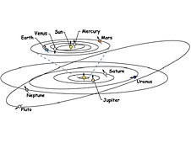
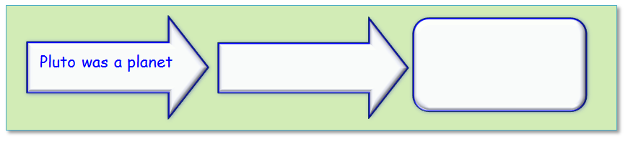
Why is Pluto Not a Planet Anymore?
My Very Educated Mother Just Served Us Nine Pizzas. This was an easy way to (1)________ the nine planets. But now the (2)________ doesn’t include any Pizza! Now, Mother Just Served Us Nachos. What happened to Pluto?
Nothing (3)________ to Pluto. We (4)________ the definition of a planet. Now to be in the planet club, there are three things that need to be true. The (5)________ is that planets orbit the sun. Pluto orbits the sun (6)________ 248 years. Next, a planet needs to be large enough to (7)________ material into a round shape. The last thing is that a planet needs to (8)________ the neighborhood. Whoops! Pluto didn’t (9)________ out the asteroids and debris in it’s orbit.
Scientists are (10)________ more about the universe and Earth's place in it. What (11)________ learn may cause them to think about how objects like (12)________ are grouped. Scientists group objects that are like each other to better understand them. Learning more about faraway objects in the (13)________ system is helping astronomers learn more about what it means to be a planet.
Word Bank

changed clear dominate every first happened learning menu planets pull remember solar they
Organize Your Thoughts

