
Name: ______________________________
Date: __ / __ / ____ Period __ Room ___
Did you know?
1 The Sun heats the Earth’s surface more in some places than others.
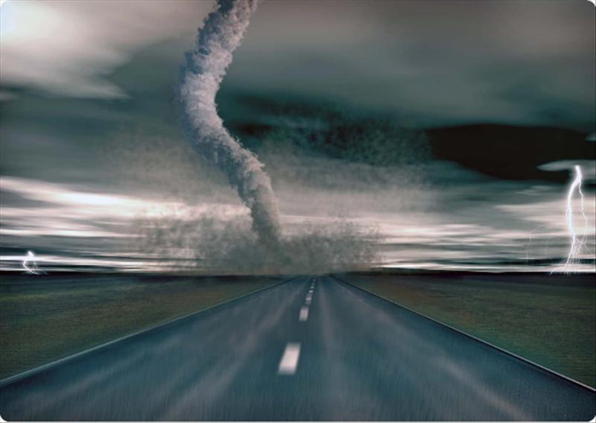Figure 1 – A tornado is dangerous.
2 Heat from the Sun causes water to evaporate from Earth’s surface. The Sun also warms the air close to the Earth's surface.
3 Warm air is light, so it rises. When this happens, heavy cool air flows in to take its place. The flowing surface air is what we generally call wind (see Figure 1).
So, why is it important to me?
4 Rain and snow come from certain types of clouds. Knowing about water in the air and how clouds form help us to know what the weather will be like later in the day.
What are the big ideas I need to know?
5 Water is heated by the Sun and evaporates into the atmosphere as water vapor. This is a part of the water cycle. Condensation happens when water vapor changes into liquid water – this is happens in clouds.
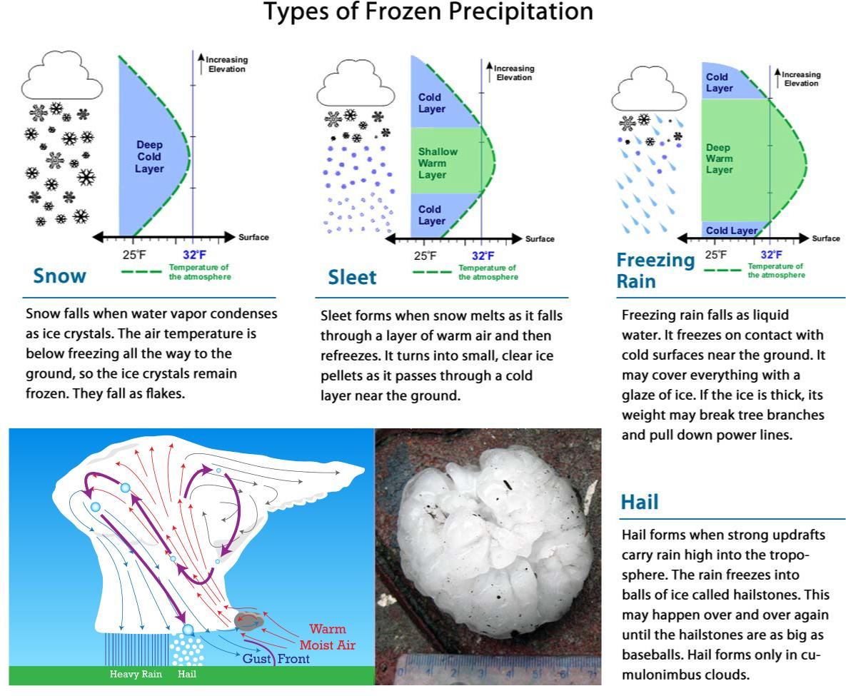
Figure 2– Different conditions make different precipitation.
6 There are several types of frozen water that falls from the sky (see Figure 2). Snow is water vapor that forms into a six sided crystal of frozen water. Sleet is rain that freezes on the way down to the ground.
7 Hail is another type of frozen precipitation. Hail forms in thunderstorms when strong updrafts carry rain high into the air. The rain freezes into balls of ice called hailstones. This may happen over and over again until the hailstones are as big as baseballs. Hail can destroy crops and damage roofs.
8 Freezing rain is simply rain that freezes when it hits trees or the ground. It is heavy and sometimes causes damage when electrical power lines break due to the added weight of the ice.
9 Clouds form when water vapor condenses in the air around specs of matter. Clouds are named on the basis of where and how they form. Three main types of clouds are cirrus, stratus, and cumulus (see Figure 3).
10 Cirrus clouds form ice crystals high in the troposphere. They are thin and wispy. They don’t usually produce precipitation, but they may be a sign that wet weather is coming.
11 Stratus clouds occur low in the troposphere. They form in layers that spread horizontally. They may cover the entire sky like a thick blanket. Stratus clouds that produce precipitation are called nimbostratus. The prefix nimbo- means “rain.”
12 Cumulus clouds are white and puffy. They may grow very tall. They grow upward because they form in convection currents. When they produce rain, they are called cumulonimbus.
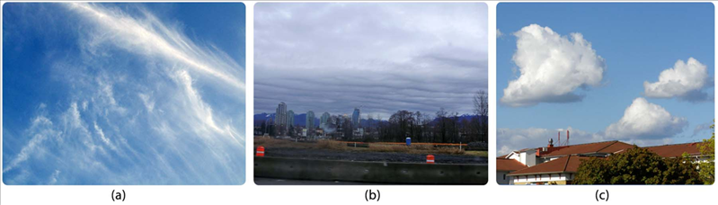 Figure 3 - Cirrus (a), Stratus (b) and Cumulus (c) clouds.

What about?
13 Weather refers to conditions of the atmosphere at a given time and place. It occurs because of unequal heating of the atmosphere. Humidity, clouds, and precipitation are important weather factors.
14 In order to make a raindrop or any frozen precipitation, water vapor must give up some heat to a tiny piece of dust, dirt or pollen in the air. In the center of every snowflake or raindrop is a small spec of dust.
15 Humidity is the amount of water vapor in the air. Like marbles in a box of basketballs, water vapor molecules slip into the spaces between the molecules of air.

