
Did you know?
1 There are two major classifications of planets, inner and outer, based on what they are made of and how far they are from the sun (see Fig 1).

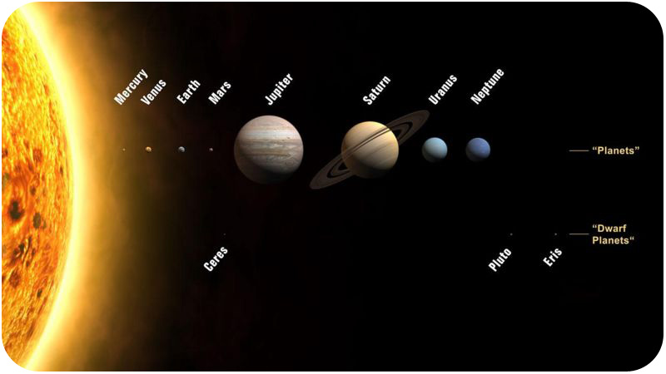
Figure 1 – Eight Planets (relative size to scale)
2 After the sun and planets formed, there was some material left over. These small chunks didn't get close enough to a large body to be pulled in by its gravity. They now inhabit the solar system as asteroids and comets. When some fall to Earth, they are called meteors.
So, why is it important to me?

3 Knowing about the planets and other bodies in space will allow us to make decisions about exploration, lessen the fear of being hit by an asteroid, and enjoy meteor showers.
What are the big ideas I need to know?

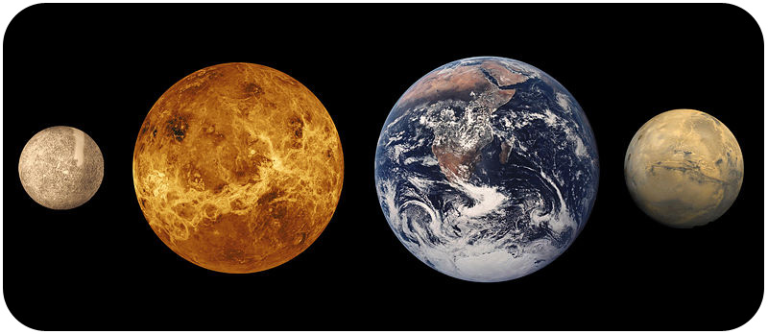
Figure 2 – Four Inner Planets Mercury, Venus,
Earth and Mars (relative size to scale)
4 The inner planets, or terrestrial (Earth like) planets, are the four planets closest to the sun: Mercury, Venus, Earth, and Mars (see Fig 2).
5 Unlike the outer planets, which have many moons, Mercury and Venus do not have moons, Earth has one, and Mars has two. Of course, the inner planets have shorter orbits around the sun, and they all spin more slowly. They are all made of cooled rock with iron cores. None of the inner planets has rings.

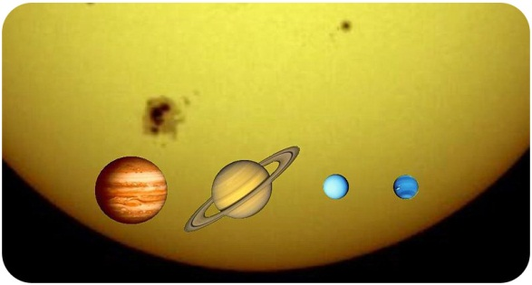
Figure 3 – Four Outer Planets, Jupiter, Saturn, Uranus, and Neptune. (relative size to scale against the sun)
6 The four planets farthest from the sun are the outer planets: Jupiter, Saturn, Uranus, and Neptune. These planets are much larger than the inner planets and are made primarily of gases and liquids, so they are also called gas giants.
7 The gas giants are made up primarily of hydrogen and helium; the same elements that make up most of the sun. Astronomers think that hydrogen and helium gases made up much of the solar system when it first formed (see Fig 3).
8 All of the outer planets have numerous moons. They all also have planetary rings, composed of dust and other small particles that encircle the planet in a thin flat plate.
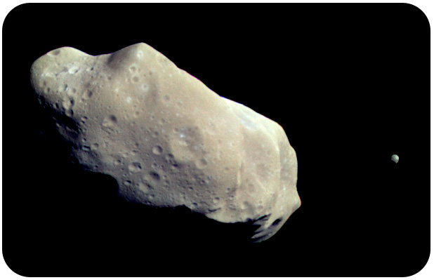Figure 4 – Asteroid Ida
9 Asteroids are very small, rocky bodies that orbit the sun. "Asteroid" means "star-like," and in a telescope, asteroids look like points of light, just like stars. Asteroids are irregularly shaped because they do not have enough gravity to become round. They are also too small to maintain an atmosphere and without internal heat they are not geologically active. Collisions with other bodies may break up the asteroid or create craters on its surface. (see Fig 4).
10 If you look at the sky on a dark night, you may see a meteor. A meteor forms a streak of light across the sky. People call them shooting stars because that's what they look like. The light you see comes from a small piece of matter burning up as it flies through Earth's atmosphere.
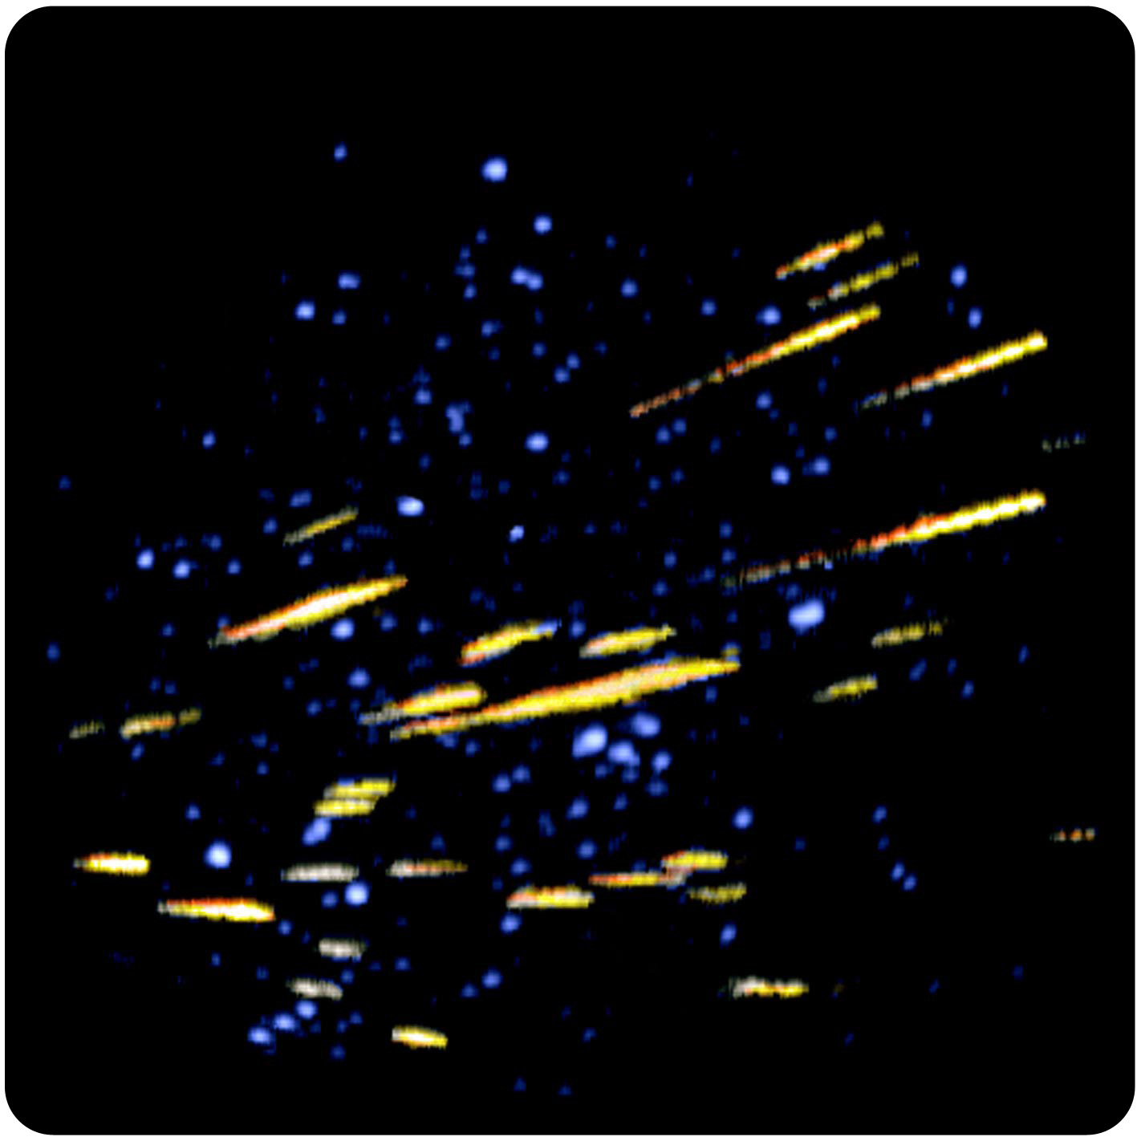
Figure 5 – Meteors
11 Before these small pieces of matter enter Earth’s atmosphere, they are called meteoroids and can be as large as boulders or as small as tiny grains of sand (see Fig 5). Large meteoroids may not burn up entirely in the atmosphere and hit the Earth’s surface. This is called a meteorite and you can hold one in your hand.
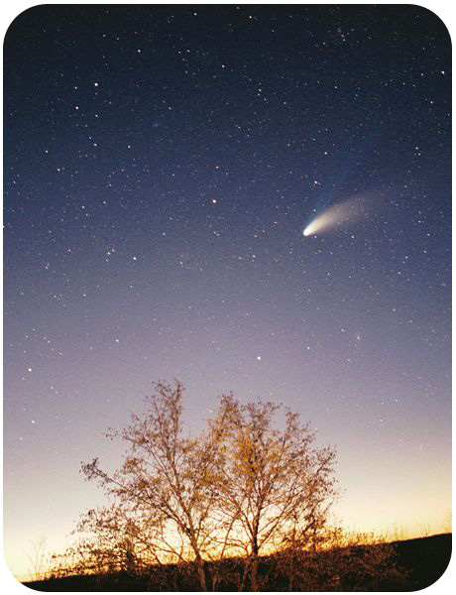
Figure 6 – Hale-Bopp Comet
12 Comets are small, icy objects that orbit the sun. Comets have highly elliptical orbits. Their orbits carry them from close to the sun to the solar system's outer edges. When a comet gets close to the sun, its outer layers of ice melt and evaporate. The vaporized gas and dust forms an atmosphere around the comet. This atmosphere is called a coma and it always points away from the sun, no matter which way the comet is moving (see Fig 6).
What about?
13 The new set of dwarf planets are exciting proof of how much we are learning about our solar system. With the discovery of many new objects, in 2006, astronomers refined the definition of a planet and put Pluto into the new category of a dwarf planet (see Fig 7).
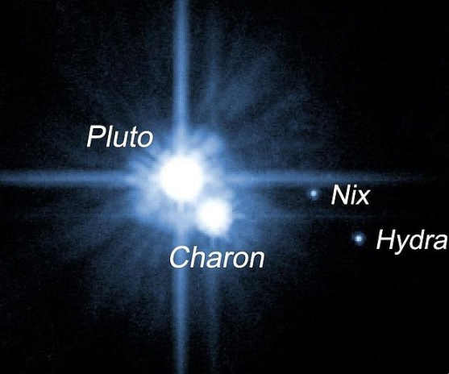
Figure 7 – Pluto and others
14 The more material or mass a planet has, the greater something would weigh. You would weigh more on a more massive planet because that planet has a greater force of gravity pulling on you.

