
Did you know?
1 Matter is anything that has mass and volume. The entire universe is composed of matter, which is in turn composed of atoms. An atom is the basic building block of all matter.

Figure 1 – Democritus
2 One of the first people to propose the existence of atoms was a man known as Democritus (see Figure 1). Unlike the other Greek philosophers, he suggested that atomos – tiny, indivisible, solid objects - make up all matter in the universe.
So, why is it important to me?
3 In the late 1700s and early 1800s, scientists, like John Dalton (see Figure 2), began noticing that when certain substances, like hydrogen and oxygen, were combined to produce a new substance, like water, they always reacted in the same proportions by mass. Among other things, Dalton found that certain chemicals always combined in a definite ratio.
What are the big ideas I need to know?
4 Dalton’s atomic theory states that:
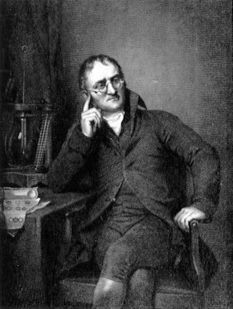Figure 2– John Dalton.
A- Matter is made of tiny particles called atoms.
B- Atoms are indivisible. During a chemical reaction, atoms are rearranged, but they do not break apart, nor are they created or destroyed.
C- All atoms of the same elements are identical in mass and other properties.
D- The atoms of different elements differ in mass and other properties.
E- Atoms of one element can combine with atoms of another element to form compounds – new, complex particles. In a given compound, however, the different types of atoms are always present in the same ratio.
5 There are 3 basic parts to all atoms: protons, neutrons and electrons. The center part or nucleus is where the protons and neutrons are found (see Figure 3). The nucleus contains most of the material in an atom as electrons are about 1/1000th of the mass of a proton (see Figure 4). Electrons orbit the nucleus like planets orbit the Sun.
6 The charges in atoms are balanced. Protons carry a positive charge, Electrons a negative charge but Neutrons have no charge at all. A neutral atom must have exactly one electron for every proton. If a neutral atom has 2 protons, it must have 2 electrons.
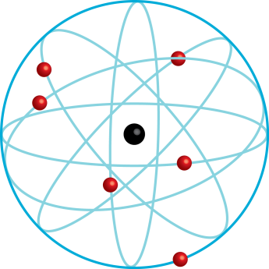
Figure 3 - Model of an atom
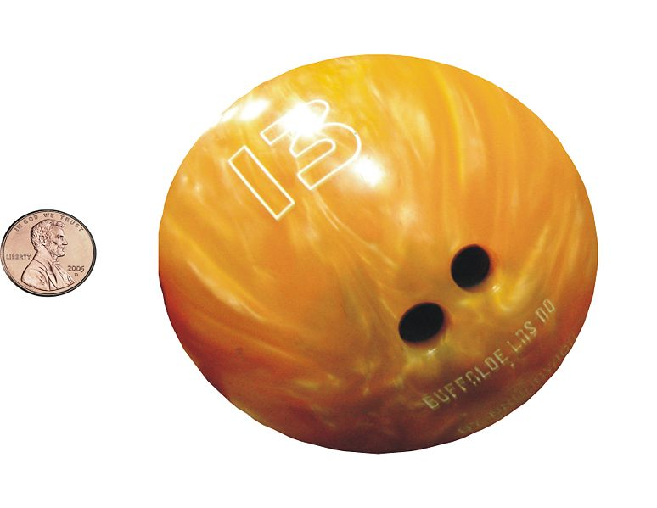
Figure 4 – If the nucleus were and mass of a bowling ball, an electron would have about the mass of a penny.
7 Atoms from two or more elements can chemically combine to form a new substance. Compounds are substances that are made up of more than one type of atom. This combination of different atoms forms a new substance with completely different properties than the atoms from which they were formed (see Figure 5).
8 Water is made up of one atom of oxygen and two atoms of hydrogen. Hydrogen is an explosive gas and oxygen is a gaseous substance that supports combustion. Yet, when these two are combined chemically to form water, the product neither burns nor supports combustion. In fact, water is used to put out fires. When elements are combined chemically to form compounds, the new substance has all new properties.
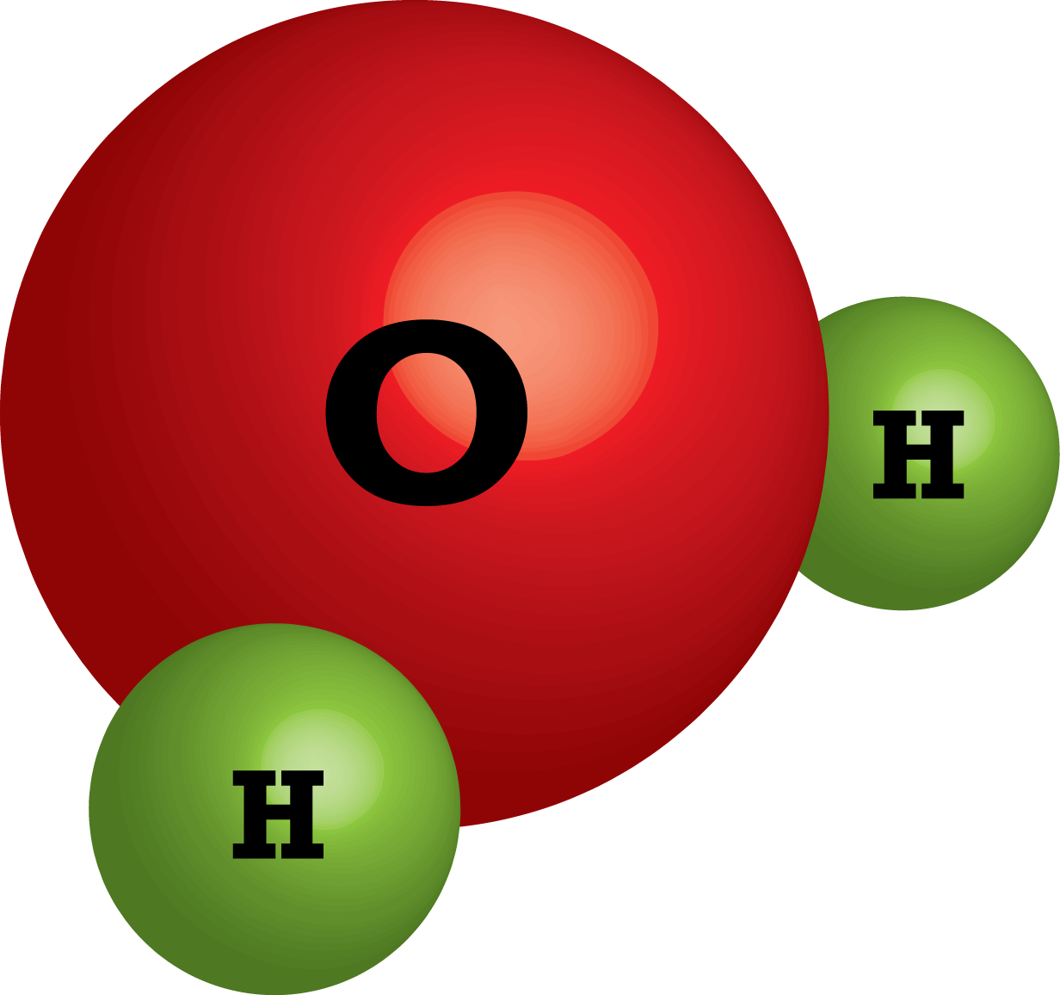
Figure 5 – Two Hydrogen atoms combine with one Oxygen atom to make water.
9 Atoms are held together in compounds by a force known as a chemical bond. Atoms in a compound share electrons. It is the sharing of these electrons that holds a compound together.
What about?

10 The Nucleus is not a particle itself. It is a word used to describe the center of an atom or the total of protons and neutrons added together.
11 There are strong nuclear forces that hold the positive Proton particles and neutral Neutron particles in the nucleus together. Remember that like charges oppose each other.

